圖片原始網頁
http://goods.ruten.com.tw/item/show?21309274034971

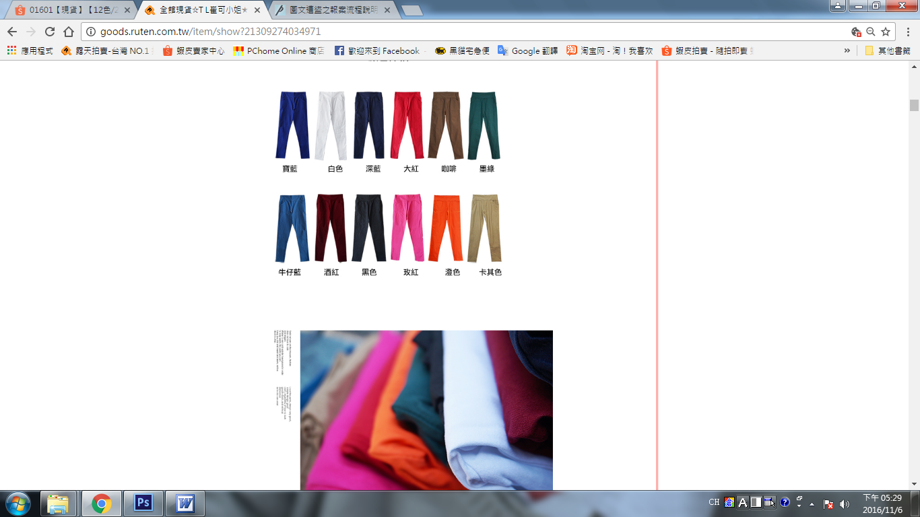

↓↓↓↓以下為盜圖者資訊---------------------------------------------------------------------
盜版網頁露天

http://goods.ruten.com.tw/item/show?21435038144443
http://goods.ruten.com.tw/item/show?21445676598894
http://goods.ruten.com.tw/item/show?21445676714322
http://goods.ruten.com.tw/item/show?21435043767552

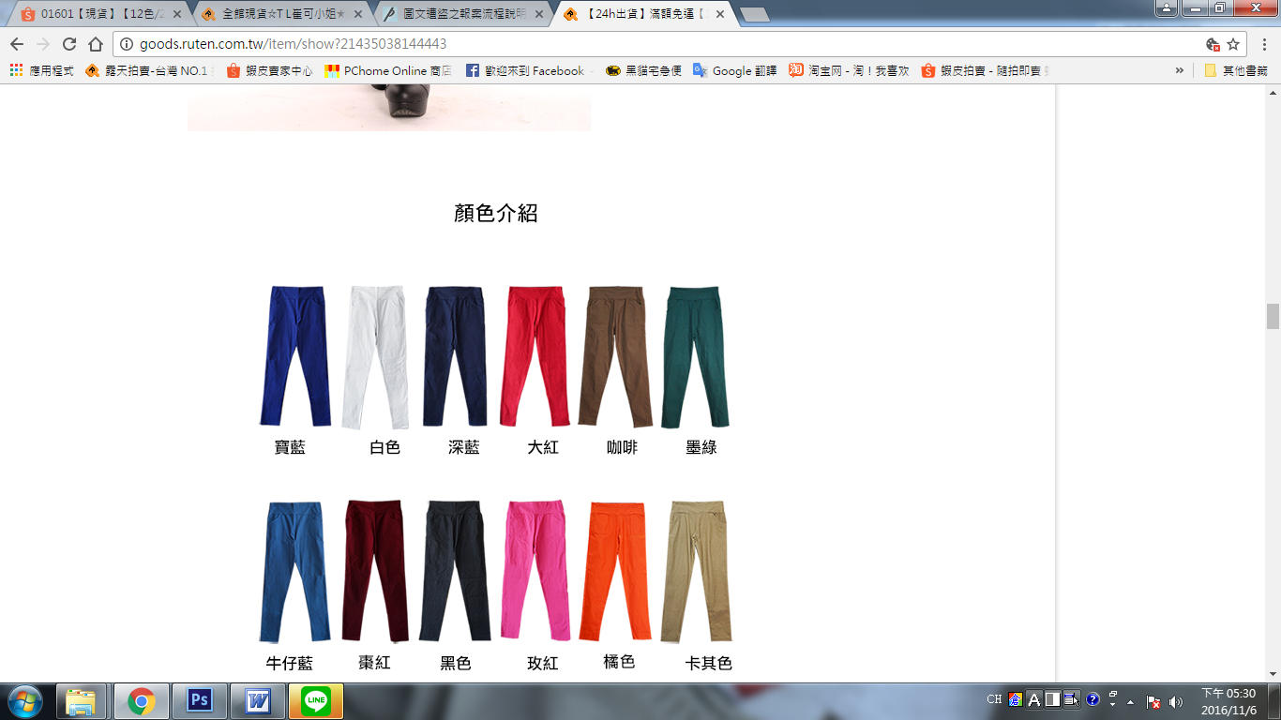
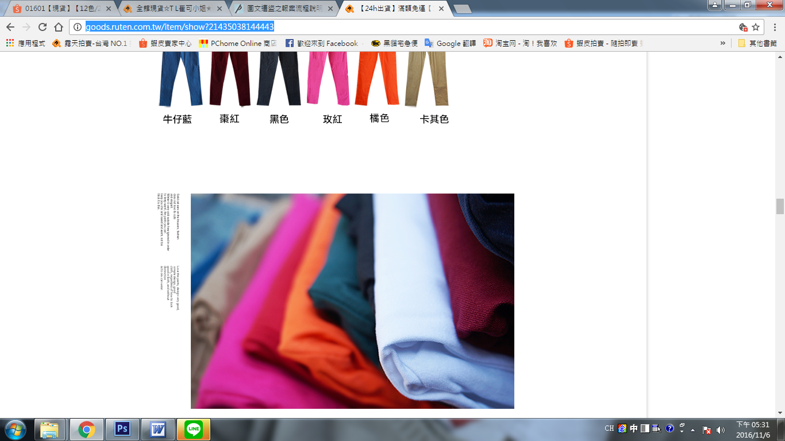

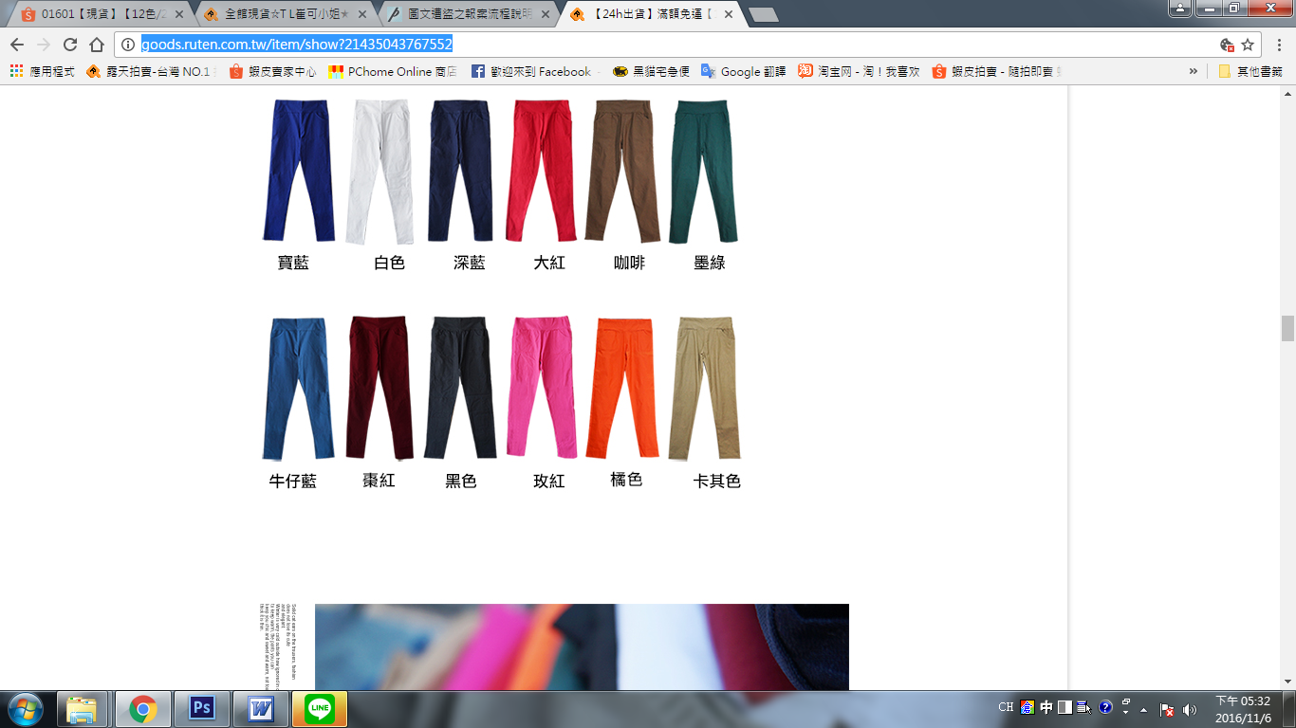

盜圖網頁 蝦皮
https://shopee.tw/01601%E3%80%90%E7%8F%BE%E8%B2%A8%E3%80%91%E3%80%9012%E8%89%B2-2%E6%AC%BE%E3%80%91%E3%80%90%E7%B0%A1%E7%B4%84-%E5%8F%A3%E8%A2%8B%E3%80%91%E9%A6%AC%E5%8D%A1%E9%BE%8D%E7%B3%96%E6%9E%9C%E8%89%B2%E9%A1%AF%E7%98%A6%E7%AA%84%E7%AE%A1%E8%A4%B2%E9%89%9B%E7%AD%86%E8%A4%B2-i.3132919.11601696

https://shopee.tw/01601%E3%80%9024h%E5%87%BA%E8%B2%A8%E3%80%91%E3%80%9015%E8%89%B2%E3%80%91%E9%A6%AC%E5%8D%A1%E9%BE%8D%E7%B3%96%E6%9E%9C%E8%89%B2%E9%A1%AF%E7%98%A6%E7%AA%84%E7%AE%A1%E8%A4%B2%E9%89%9B%E7%AD%86%E8%A4%B2-i.6239616.28749751

https://shopee.tw/01601%E3%80%90%E7%8F%BE%E8%B2%A8%E3%80%91%E3%80%9012%E8%89%B2-2%E6%AC%BE%E3%80%91%E3%80%90%E7%B0%A1%E7%B4%84-%E5%8F%A3%E8%A2%8B%E3%80%91%E9%A6%AC%E5%8D%A1%E9%BE%8D%E7%B3%96%E6%9E%9C%E8%89%B2%E9%A1%AF%E7%98%A6%E7%AA%84%E7%AE%A1%E8%A4%B2%E9%89%9B%E7%AD%86%E8%A4%B2-i.3132919.11601143

https://shopee.tw/01601%E3%80%9024h%E5%87%BA%E8%B2%A8%E3%80%91%E3%80%9015%E8%89%B2%E3%80%91%E9%A6%AC%E5%8D%A1%E9%BE%8D%E7%B3%96%E6%9E%9C%E8%89%B2%E9%A1%AF%E7%98%A6%E7%AA%84%E7%AE%A1%E8%A4%B2%E9%89%9B%E7%AD%86%E8%A4%B2-i.6239389.28787773

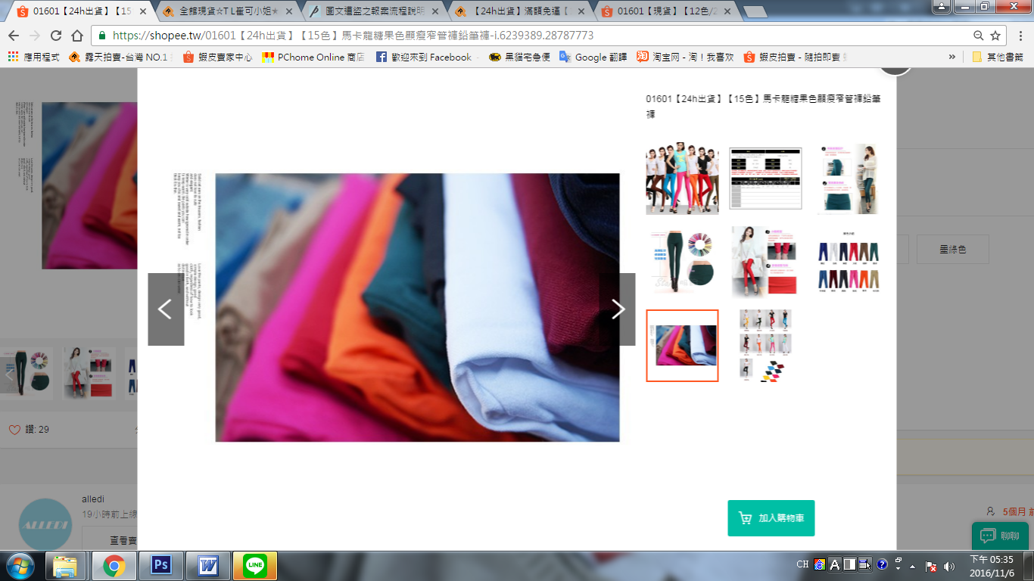

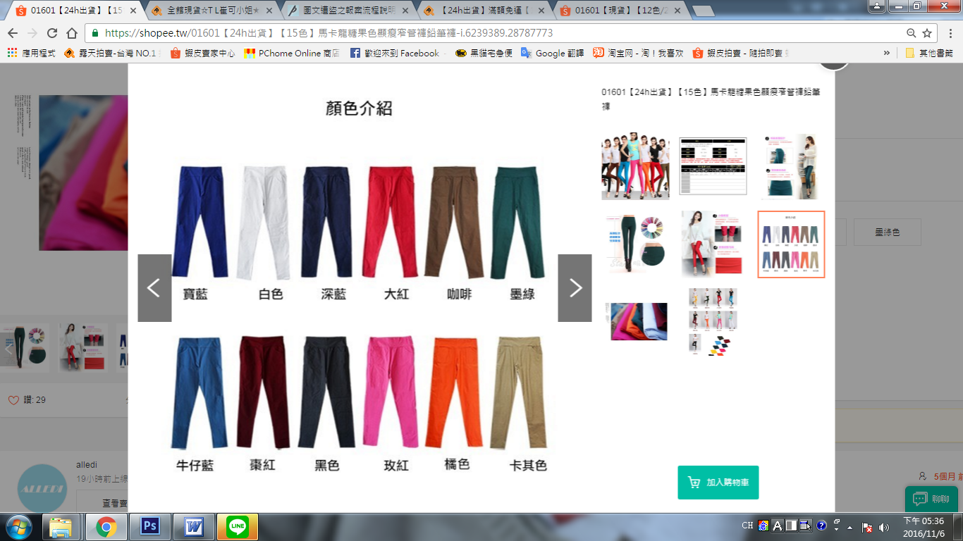

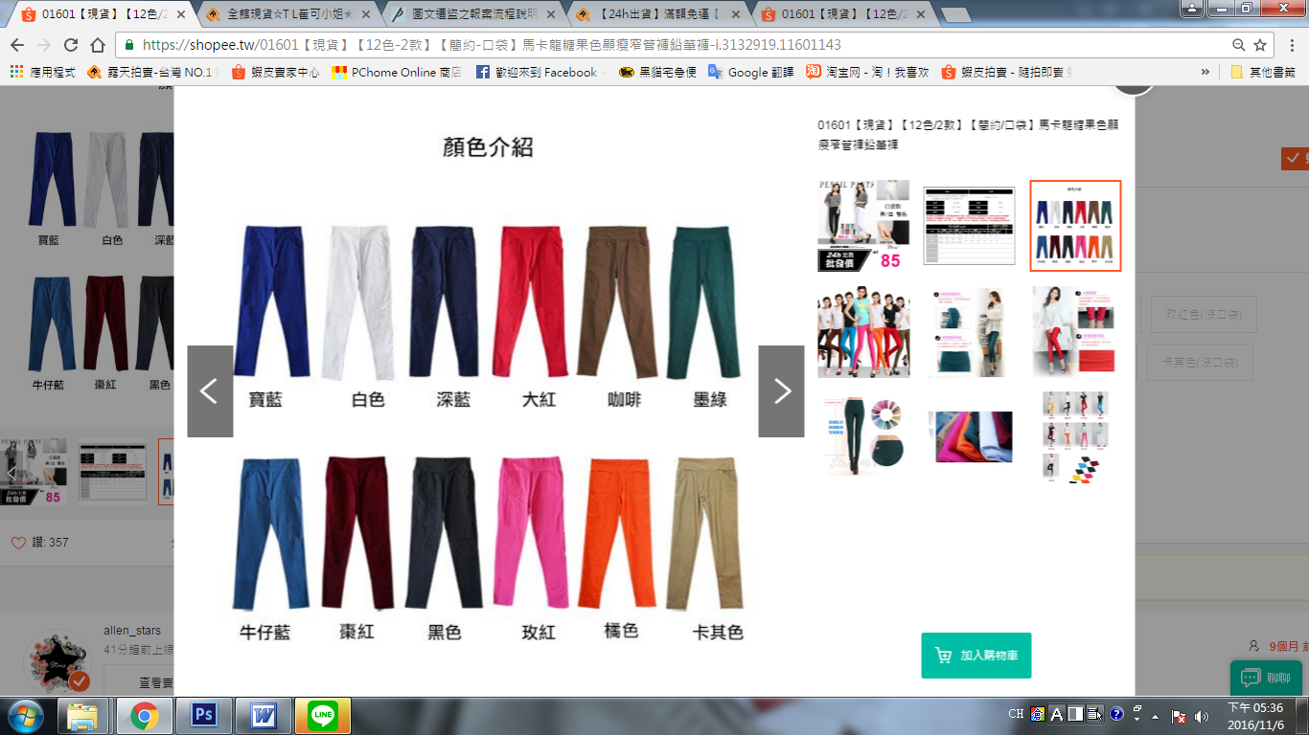

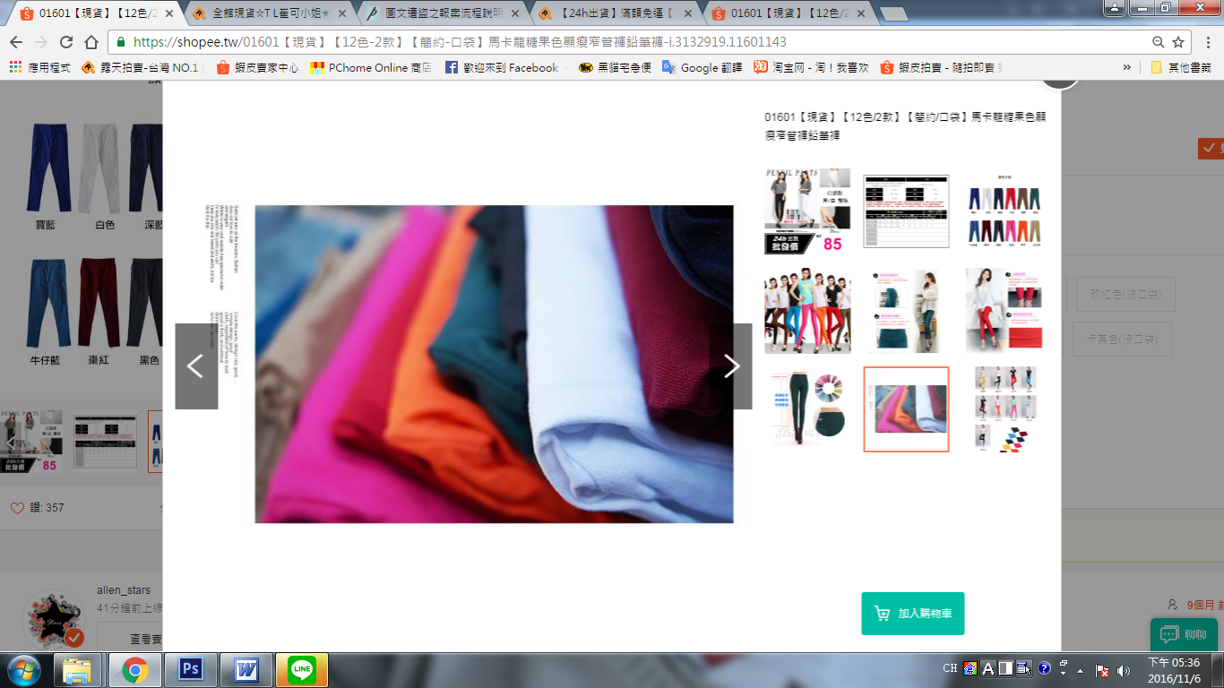

以下為告知二次,二版留言
